HRI-Robot based on Bloosom

System Overview

Richard Zhou

# System Architecture

## System Requirement

|  |  |  |
| --- | --- | --- |
| Component | Mandatory/Optional | Description |
| Bloosom Robot | Mandatory | 4 Dyanximel XL320 motors. |
| Arduino Giga R1 | Mandatory |  |
| Dynaximel Shield extension board | Mandatory |  |
| PC | Mandatory |  |
| Camera | Optional (if using laptop with internal Camera) |  |
| UART-USB adapter | Mandatory |  |

## Hardware architecture

The hardware components and connectivity are shown in the following figure.

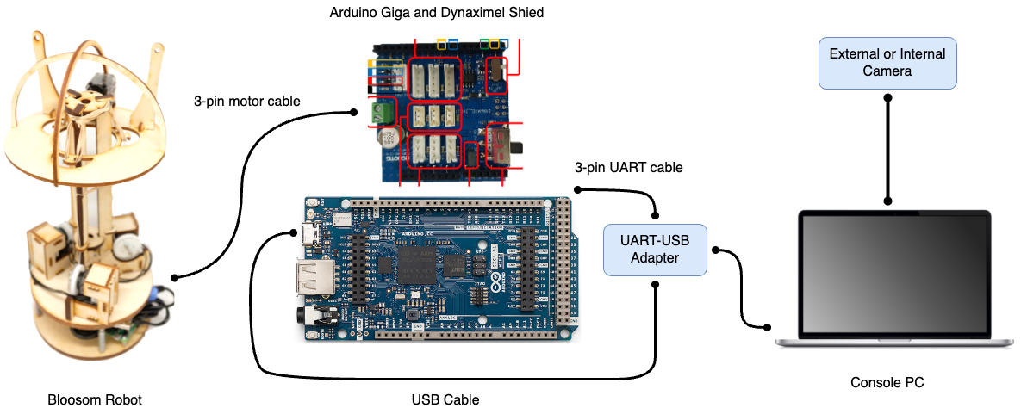

Figure-1: Components and connectivity.

Table-1: Wiring definitions

|  |  |
| --- | --- |
| Wiring | Description |
| 3-pin motor cable | Power supply, and instruction/status packet communication. |
| 3-pin UART cable | Command channel between Robot and Console PC. |
| USB Cable | When the system is working, the corresponding serial port is occupied by Dynaximel Shield. This port is also for program uploading. |

## Software Architecture

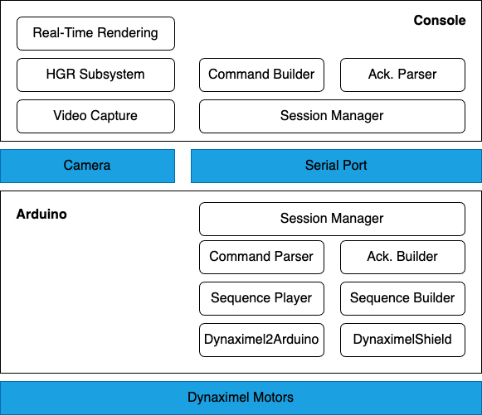

Figure-2: Software Architecture.